
Main Road, Smalley Derbyshire DE7 6EF
01332 880317
Executive Headteacher – Mrs P Atwal

Tuesday 24th February 2026
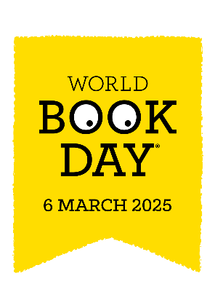
Dear Parents/Carers,

To coincide with World Book Day 2026, we will be having a special reading week in school from Monday, 2nd March – Friday, 6th March 2026. During this week, there will be lots of exciting opportunities and experiences for your child to be involved in, including special assemblies, a class visit to the Book Fair and online events.

DRESSING UP ON WORLD BOOK DAY

Options for the day:
- Dress as a book character
- Wear (appropriate) PJs/onesie
- Wear your own comfy clothes
- Wear your school uniform/PE uniform

It is World Book day on Thursday, 5th March 2025. The 2025 theme is ‘GO ALL IN’!
To help to mark this special event, children will have the opportunity to dress as their favourite book character, should they wish. It is not necessary to spend lots of money on this as homemade costumes can be just as effective. Should you not wish to dress as a book character, you are equally welcome to wear (appropriate) PJs/onesie for the day, to feel comfy and curl up with a book during the day. There is also the option to ‘dress as a reader’ by wearing your own clothes, as long as you bring your favourite book with you!
Children are encouraged to bring in their favourite book from home. We look forward to enjoying this day together. It is of course optional, and children may prefer to stay in their school uniform. If it is a P.E. day, activities will be tailored accordingly.

POP UP LIBRARY- Monday 2nd March – Friday 6th March 2026- We are excited to announce the return of our pop-up library. Parents and family members are invited each morning to come and share a book and a drink with your child. Please come to the bottom gate at 8.50am with your child to take part. The days for each class are as follows:

Monday – Class R and Class 6 Tuesday – Class 1 and Class 5
Wednesday – Class 2 Thursday – Class 3
Friday – Class 4

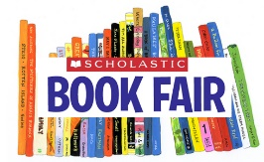
SCHOLASTIC BOOK FAIR - We’re so pleased to announce the Book Fair will be at school from Thursday 5th March – Tuesday,10^{h} March 2026, and will run after school. The Book Fair will run daily, in the school hall from 3.15-4.00pm.
Books can be purchased by paying electronically (using a QR code we will provide) or with cash. Every child will receive a World Day Book token worth £1, which can be used towards the price of a book at the book fair or at any participating book shop.

WORLD BOOK DAY COMPETITION – We have a competition running in the lead up to World Book Day. We would like you to read your favourite books in different places and send a picture to the info@richardson.derbyshire.sch email for this to be displayed in school. A winner will be selected from each class and will receive a £5.00 voucher to spend at the book fair.
The competition closes on Friday 6th March 2026.

Kind regards,
Mrs P Atwal


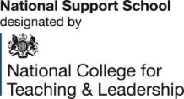
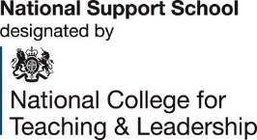
www.embarkfederation.com

