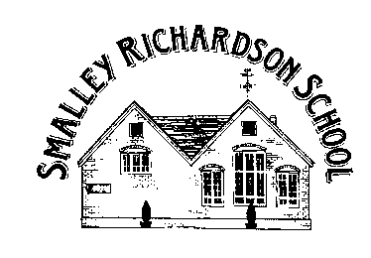

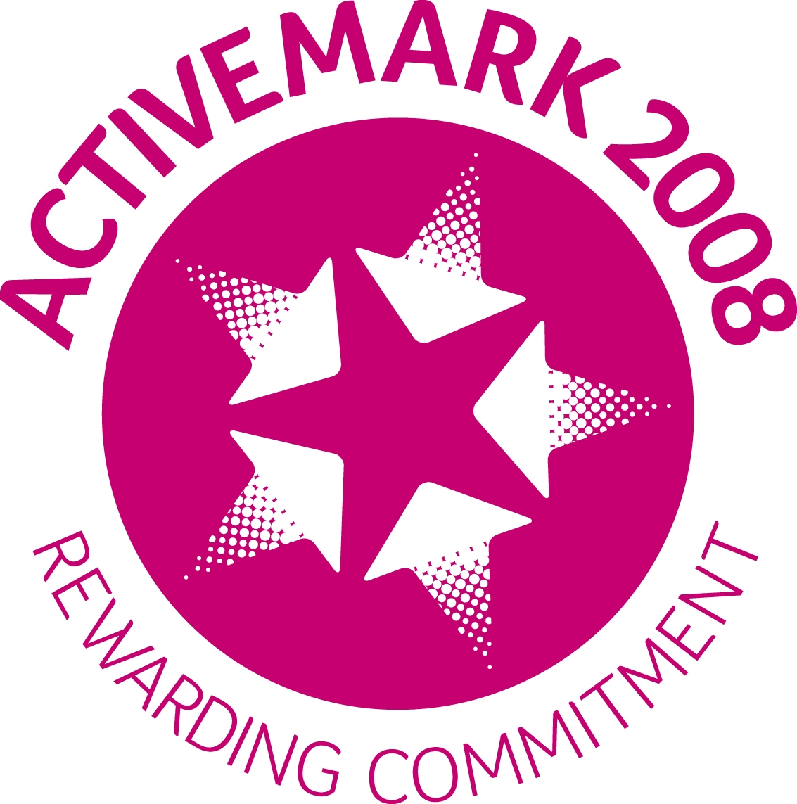

Headteacher: M Crawford

Telephone 01332 880317
Main Road, Smalley
Derbyshire DE7 6EF
30 July 2026

Gold September

Dear Parents,

As a school we are supporting Gold September again this year. It is a charity that is particularly close to our hearts as it has been set up in memory of Eddy Parry who attended our school before he tragically passed away after suffering with Bone Cancer.

I am delighted to inform you that Gold September has been successful in becoming a registered charity over recent months. The charity has been set up to raise awareness of childhood cancer and to fund research for cancer types that mainly affect children and teenagers. The charity has already formed close links with medical professionals conducting research in Oxford University, Birmingham and Nottingham hospitals.

There are a number of ways you can support us during this month:

- You and your children could wear a Gold September badge. These can be purchased from the office for a minimum donation of £1.

- One of our parents and a trustee of the charity, Jamie Eaton has organised a sponsored walk up Derbyshire’s highest peak ‘Kinder Scout.’ This will take place on Saturday 17th September and promises to be a great day out and suitable for the whole family. Please see the sheet attached and sponsor form with more details. It would be great to see as many of you as possible on the day. If you cannot make the day but you or your children would like to do an activity of your own to raise money for the charity that would be fantastic too.

- We are updating our playground during this month with money that has kindly been donated by the PTFA. As part of the playground design, there will be a lasting memorial for Eddy as he loved this part of school so much. On 30th September, we will unveil the playground and invite Eddy’s parents in the afternoon to officially open it. We also aim to plan time after school for everyone to enjoy a BBQ or coffee and cake depending on the weather forecast! More details will follow. We ask all children to dress up as a Superhero on the day to support the Gold September theme ‘Be a Hero for a Hero.’ Please do not go to great expense buying new fancy dress items. We are asking for a donation of £1 for the non-uniform day. It should be a brilliant day to end the month and will be a fitting tribute for such a special boy.

If you have any other ideas about how you would like to support Gold September at any point during the year please do not hesitate to contact myself, Mrs Evans or Jamie Eaton. Ideas could be Gold September being a business’s chosen charity for the year; you may wish to choose the charity for a personal goal, eg. half marathon etc. Many thanks for your support with this; it is much appreciated by all at school and Gold September.
Yours Sincerely,

M Crawford
Headteacher

