

Main Road, Smalley Derbyshire DE7 6EF  
01332 880317  
**Headteacher – Mr M Fearn**

**Spring 2 in Class R**

Welcome back to a new half term; we hope you have had a lovely break together. Thank you for all your warm wishes as I returned to school this week – it has been so lovely to see all of your children and to be able to continue in their learning journey together, once more. A special thank you to Mrs F.S, Mrs Hull, Mrs Gregory and Mrs Needham for teaching my class in my absence – it has been super hearing all about the children’s learning and their adventures.

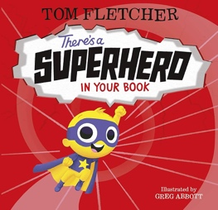We’re very much looking forward to the term ahead, which is called – SEARCH FOR A HERO! This week we launched into our Superhero week by thinking about the superheroes we know and reading a book called ‘There’s a Superhero inside your book.’

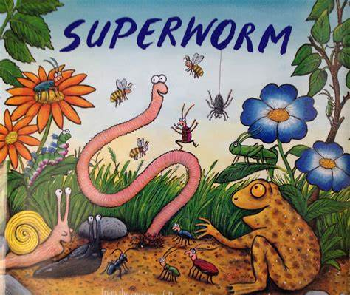As the term continues, we will be sharing the Julia Donaldson book – ‘Superworm’! We will be enjoying the story together and hope to discover some worms underground so that we can build our own wormery!

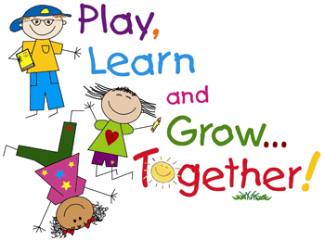

We will also be exploring real life superheroes – those people who work in our communities to make them the safe and successful places that they are.

**Calling all odd socks!** Please may we request the children bring in an adult sock, stocking or pair of tights by Monday 18th March 2024 for them to make their own ‘Superworm’!?

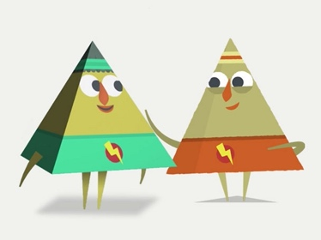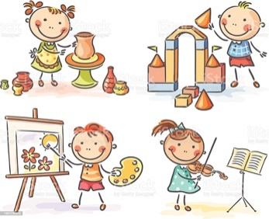Our musical creativity will be inspired by the superheroes and our community. We will continue to explore colour mixing and working with different tools and materials to create different effects. In our PSHE, we will look at community heroes and talk about people we trust.

Our Maths will continue to look at numbers 9 and 10 including doubling numbers, knowing one more and one less, counting forwards and backwards and learning our number bonds to 10. We will also explore 3D shape, addition and subtraction and measuring liquids in lots of practical and problem-solving ways.

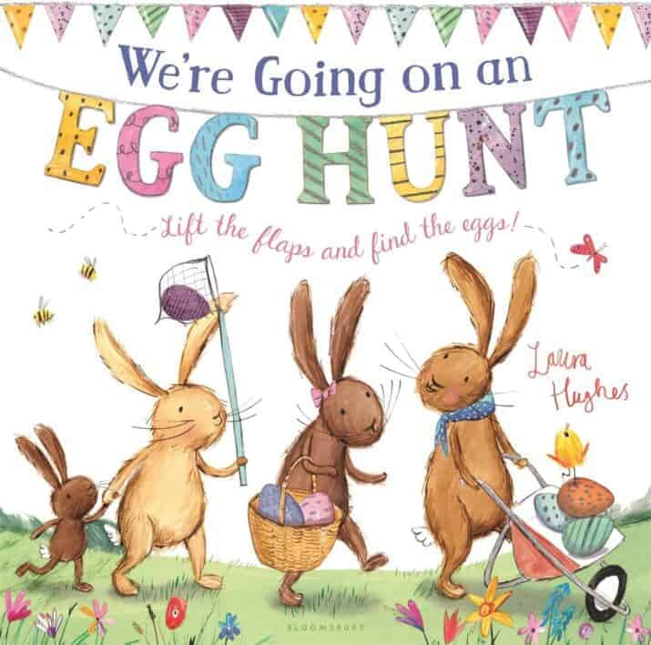

In the final week before the Easter break, we will be basing our learning on the book ‘We’re going on an Easter Egg Hunt’ where we will start to explore what Easter is and learn about some of the traditions involved in this special time – including Easter egg hunts, egg decorating and egg rolling of course!

An element of our planning will continue to be driven by your children’s interests and reactions to the stories and the learning that they do. We will continue to plan and work within the seven areas of learning in the Early Years Foundation Stage (EYFS) with a focus on the PRIME AREAS - Communication and Language, Physical Development and Personal, Social and Emotional development.

**Teddy Adventures**

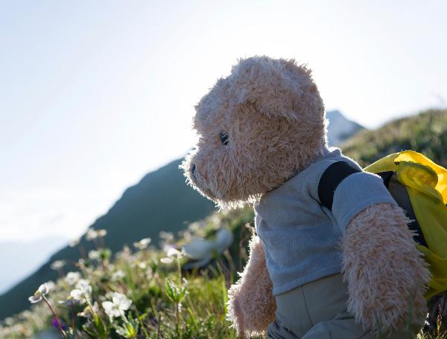We’re looking forward to seeing our little teddy friends – if your child’s teddy has gone on its own adventure (is lost) please let us know as we can sort a replacement for a small cost. At the end of the year, we hope to have a Teddy Bears’ Picnic and it would be lovely if all of the bears could attend. Please continue to upload your photographs to the folder in Google Classroom – it can be anything from watching a favourite TV programme together, playing in the garden, reading a favourite book, eating your favourite dinner to going on a local walk. Children really enjoy sharing their photographs on the big screen and it is a great opportunity for your children to speak to an audience and for the audience to ask children questions – we share these every Friday afternoon.

**Welly Wednesday**

‘Welly Wednesday’ kick-started this week with searching for daffodils in our school grounds to celebrate St David’s Day. During the rest of the term, we will search for worms, discover the signs as the season changes from Winter to Spring and start to prepare our mud kitchen for the growing of vegetables next half term.

We will send puddle suits and wellies home at Easter for a freshen up – thank you.

**Reading**

Thank you for all your continued support with your child’s reading development. The regular practice at home of their phonic books helps your child in school. We ask that your child continues to read their school book at least 3 times a week for about 5 minutes each time – this regular reading helps your child to practise and consolidate the skills that they learn every day in our Phonics sessions and in our continuous play. Your child continues to have the chance to climb up the Reading rainbows and receive certificates for each cupcake they reach; small rewards are given at 50 and 100 reads. We count up reads of their school book on a Thursday and then celebrate these in class on a Friday morning.

Developing and encouraging a lifelong love of reading is our aim here at Richardson Endowed Primary School; Story time will continue to be a treasured experience for all of our children and we have lots of beautiful books to listen to and share. Your child will have the opportunity to vote for the story they would like to hear at story time by using a token system in the classroom. Please continue to share stories at bedtime: it really is such a special time to indulge in literature – we’ve heard some lovely stories this week about characters that parents and grandparents have created. Please have a read of this article which highlights the benefits of reading bedtime stories: <https://www.theschoolrun.com/11-reasons-read-bedtime-story-every-night>

**PE**

PE lessons will continue to be on a Tuesday and Thursday morning; Please send your child in their PE uniform on these days – please ensure they have something warm on, as they will be accessing outdoors during learning time and at lunchtimes. We will continue to develop our ball skills, including throwing, aiming at a target and exploring different ways of passing a ball. If your child has earrings, please make sure these are taken out at home. Our policy is not to allow them to be covered with tape.

**Lunch**



At lunch time, we continue to help your child build their independent skills with holding their knife and fork; we support and encourage your child to cut their food into bite-sized pieces. Please continue to support this at home.

**Snack time**

Children are encouraged throughout the day to drink from their water bottle and keep hydrated. Thank you for supporting us with our **water only** policy which promotes and supports oral hygiene. Cool Milk continues to provide our fresh milk and is free if your child is 4. Once your child is 5 and they would like to continue to have milk, then you will need to sign your child up to the milk scheme. This half term our fruit selection will include pears, carrots, apples, oranges and bananas. Please feel welcome to send your child with a fruit snack if they are having a growth spurt or prefer a different fruit or vegetable. Just one snack per day is sufficient, thank you.

**Spare clothes**

We are looking for any donations of uniform to top up our spare clothes boxes including polo shirts, trousers and jogging bottoms, as well as clean underwear. If your child has outgrown theirs, please consider donating it to school. If your child has borrowed any in the past, please return to school – thank you.

**Communication**

We will continue to use GOOGLE CLASSROOM to send links and activities, as well as share Teddy Adventures. WOW moments can be shared through Google Classroom or can be written in your child’s reading diary – these can communicate those moments that your child does something for the first time or really grasps something, as well as sharing things that your children are finding tricky, so we can help at school. As always, please contact me through the school office, or catch me at the end of the school day to ask any questions or share news with me.

Thank you so much.

Enjoy your weekend together.

Kindest wishes

Mrs Reckless (Class teacher), Mrs F.S. (Class supply teacher), Mrs Hull (EYFS Teaching Assistant), Mrs Gregory (HLTA) & Mrs Needham (Teaching assistant)

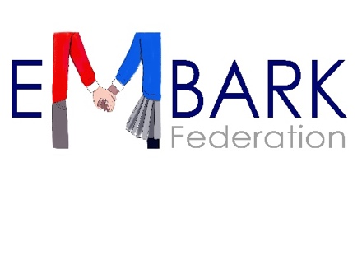



**www.embarkfederation.com**