[](http://richardsonendowedprimary.typepad.com/)

Main Road, Smalley Derbyshire DE7 6EF  
01332 880317  
**Headteacher – Mr M Fearn**

Autumn 2 in Class R

Welcome back to our new half term!

It has been a joy to welcome your children back into school this week. We feel so lucky to be sharing those special ‘first time’ moments with your child and your family and we appreciate your support and kindness very much. I apologise for my illness before half term and I am very much looking forward to seeing you next week to discuss how your child has settled into school.

**THIS HALF TERM**

A big well done to your children who have enjoyed being back together again and enjoyed one another’s company as they have helped each other to remember all of the routines that they have learned so far. We have been speaking a lot about what has stayed the same and what is different in our classroom.

All of our learning this half term will be based upon a topic called ‘Awesome Autumn’, looking at traditions, festivals and the changes in nature. This week, we explored some of the traditions associated with Halloween and then have started to explore what we understand by autumn. We have started to look for signs that tell us that autumn has arrived. We will be exploring the autumnal festival of Diwali and the traditions of the 5th of November. We will talk about firework safety and learn about Guy Fawkes. Over the coming weeks we will look at Remembrance, and how different animals hibernate as the weather gets colder.

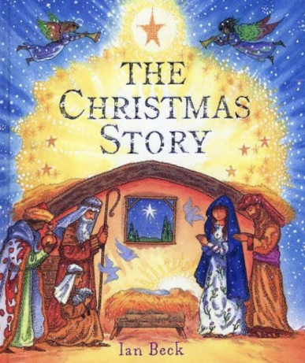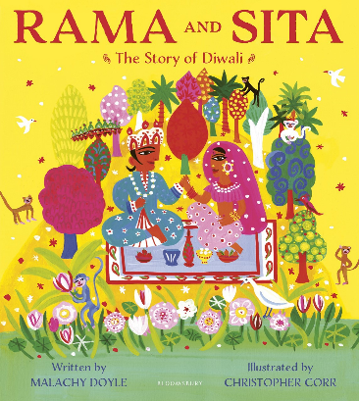Our learning journey will be inspired by some well-chosen texts including a selection of autumnal poems and songs, a story about hibernation called ‘Don’t hog the hedge’, a beautiful story book called ‘Rama & Sita – The Story of Diwali’ and a gorgeously illustrated book called ‘The Christmas Story’. As well as reading the rhymes, poems and stories, we will be learning about the Hindu and Christian faiths and why these stories are so special to them. Through a mixture of play, whole class, small group and individual focus groups, we will be planning and providing lots of active learning activities for the children to participate in that will help each child continue to make progress towards the Early Learning Goals. An element of our planning is driven by your children’s interests and reactions to the stories and the learning that they do. We will continue to plan and work within the seven areas of learning in the Early Years Foundation Stage (EYFS).

Smalley Teddies

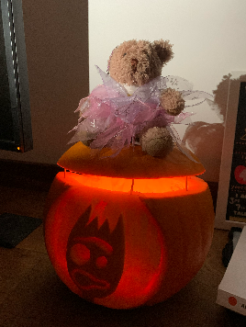

Our teddies continue to be a gorgeous addition to our classroom – providing support when needed. We’ve discovered that a few of them like to get up to mischief, some just give the best cuddles and others like to have a cheeky nap in the children’s trays! We will continue with Teddies’ Adventures, so please upload the photographs to Google Classroom. Each Friday, the children share their photos with the whole class and get much pride from doing so. Thank you if you have logged onto Google Classroom – please contact school if you require help with this.

It might be a little early to mention the ‘C’ word but we would love the teddies to have a little Christmas sparkle about them in December so please start thinking about an addition to their outfit!

Welly Wednesday

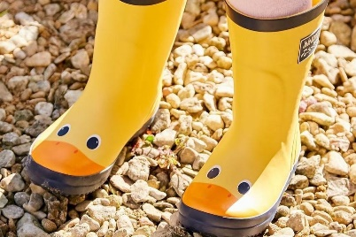

In our Welly Wednesday sessions this half term, we will focus on the change in seasons from autumn to winter.

Buddies

Your child has enjoyed meeting their buddy and getting to know them. The aim of the buddy system is to encourage a supportive and guiding friendship between our youngest children and our eldest children in school, where caring role models and an excitement to learn are shared.

The buddy role involves supporting lunch play (this is on a rota), supporting the children in assemblies (where required) and spending quality time, which encourages development with language and personal skills and responsibilities. Through the term, there are special events where Year R and Year 6 team up – this term there will be a reading event in November and a Christmas craft event in December.

Some children have spoken to us about buying gifts for their buddies and we thank you and your families for their generosity and kindness. There has never been an expectation to exchange gifts but if you choose to, please can we ask that these be given at Christmas or at the end of the school year.

Reading

Thank you for all of your support with helping your child to practise their reading at home. There continues to be lots of bedtime stories shared and enjoyed.

In Class R, we ask your child to read their school book at least 3 times a week for about 5 minutes each time – this regular practice helps your child to practise and consolidate the skills that they learn every day in our phonics sessions and in our continuous play. It is such a special time as your child starts to read and becomes more aware of the environmental print that surrounds them. The ‘Teach your monster how to read’ computer programme will support your child’s phonic journey – we have received some really positive feedback about this app – thank you.

This term we will begin our reading reward certificates. For every 10 reads of their school reading book, your child will receive a certificate and small rewards along the way. We count up reads of their school book on a Thursday and then celebrate these in class on a Friday morning.

Early reading is special but also hard work and your child is working so hard to learn that words start with different sounds, to decode the words by segmenting the sounds and then blending together and remembering those words from page to page. You may find that your child is working so hard on this that they may not understand what they are reading. For this reason, we are encouraging your child to keep the same reading book for a few nights so that they can reread the book again or practise and talk through what they have read. This familiarity builds your child’s confidence as well as improving their sight vocabulary.

In the front/back of the new reading books we have purchased, there are some super question prompts that help you to see the types of questions that we use with your child at school. As your child’s book becomes longer and has more words in it, then you may find that it will take a couple of nights for your child to read the whole book – this is fine and we would prefer that you reread a book over a few nights with your child as they will then be able to focus on understanding the story rather than just decoding the words. If you have questions about your child’s reading, please contact us, as we are always happy to talk through your child’s journey.

If your child is tired or reluctant to read one night, then please be guided by them and share a story instead. We always try to encourage reading to be a pleasurable experience rather than a chore or battle.

We will aim to change reading books on a Monday, Wednesday and Friday.

Our website

We will continue to share our learning on our school website: <https://richardsonendowed.co.uk/> Thank you for taking the time to have a look.

PE

PE lessons will continue to be on a Tuesday and Thursday morning; we will be exploring dance and movement as well as playing team games. If your child has earrings, please make sure these are taken out at home. Our policy is not to allow them to be covered with tape.

Snack time

Children are encouraged throughout the day to drink from their water bottle and keep hydrated. Thank you for supporting us with our **water only** policy which promotes and supports oral hygiene. Cool Milk continues to provide our fresh milk and is free if your child is 4. Once your child is 5, if they would like to continue to have milk, then you will need to sign your child up to the milk scheme. This half term our fruit selection will include pears, carrots, apples, oranges and bananas. Please feel welcome to send your child with a fruit snack if they prefer a different fruit or vegetable. Just one snack per day is sufficient, thank you.

It’s a pleasure to see how confidently your child continues to come into school each morning; they seem to have grown up so much in a short amount of time! I look forward to speaking with you all next week at our Parents Evenings to discuss how your child has settled in and how they are developing on their learning journey.

If you have any questions or require any support, please do not hesitate to contact me via the school office or at the end of the day.

Have a safe and cosy weekend together.

Mrs Reckless (Class teacher), Mrs Hull (Teaching Assistant) & Mrs Gregory (HLTA)



**www.embarkfederation.****com**